The Cunning Caracal: A Sport-shooting alternative?
The Austrians are amazingly clever people. Not only did they manage to convince the world that Beethoven was born an Austrian and that Hitler was born in Germany (when actually the birth certificates of these two fellows prove that it was the other way around) - they have also made an indelible mark on the world of firearms and hunting with their outstanding quality Glocks, Steyrs, Mannlichers, and Swarovskis. In keeping with our globalised village, Steyr engineering recently snuck off into the deserts of Arabia to assist in the birth of a new, and impressive semi-automatic pistol named, somewhat aptly, the “Caracal”. The hardy cat for which it is named; “caracal caracal” or “Rooikat” as it is commonly known in south Africa, covers a vast territory stretching all the way from Cape Augulhas to India and is still alive and well today in the sparse scrub of the United Arab Emirates, where its namesake pistol is now being produced for the police and armed forces as well as for civilian export.
Full size top – Compact at bottom
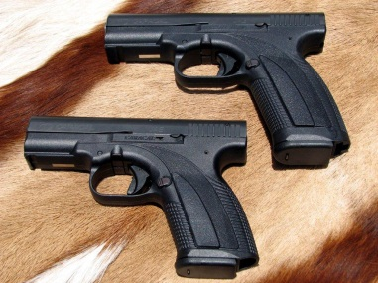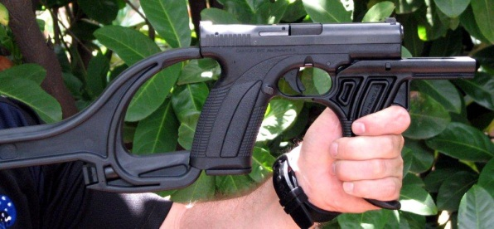
Imitation remains the sincerest form of flattery and it is therefore unsurprising that the Caracal shares the majority of the Glock’s features right down to the same field stripping method for cleaning purposes. The familiar looking finish is also claimed to be as hard wearing as the Tennifer process used by Glock. Two 9mmP models, the compact Caracal C with a magazine capacity of 15 and the full sized Caracal F holding 18 rounds in the magazine are currently available in South Africa. Four features of these offerings immediately struck me positively. Firstly the full size model is optionally available in a hard cased version containing the pistol, a detachable stock, a sturdy forehand grip attachment, three magazines and a well-constructed magazine loader. The detachable stock and fore-end swiftly turns the pistol into a handy carbine with the potential for maintaining a sustained firepower for the most exacting sport shooting scenarios - 55 round (3X18 plus 1). This conversion is also able to incorporate a light, laser or combination of both. The second pleasant surprise was the ergonomics of the grip. The weapons, both compact and full size, are slimmer in the hand and the trigger reach for smaller hands is a considerable improvement on that of the comparable Glocks. Thirdly the standard feature of an ambidextrous magazine release brings further versatility to what appears to be a very well-engineered pistol. The last and most pleasing revelation was the sear release on the trigger. While the trigger itself incorporates the same safe action made famous by Glock, making it impossible to fire unless the lever in the middle of the trigger is depressed, the actual break felt lighter and less “mushy” than that of the Glock. In keeping with the new breed of firearms, provision is made for laser or light attachments in front of the trigger guard below the barrel.
The feature I personally least liked on this weapon was the sighting arrangement. The set up on the Caracal, with two white dots - one at the back and the other on the front sight are apparently designed to form a figure of eight for a “clear sight picture”. The rear dot, in my view, merely serves to remove the shooters attention from the all-important front sight and my first action if the pistols were mine would be to permanently black out these rear dots. Even for deliberate target shooting – which is after all NOT the role of these firearms – the sighting arrangement did not work well for me. Fired at twenty metres the five shot groups were adequate but did no great justice to the guns as I am sure that with a more conventional sight picture they would have shrunk somewhat. Ironically the compact did a tad better than the full size in this test.
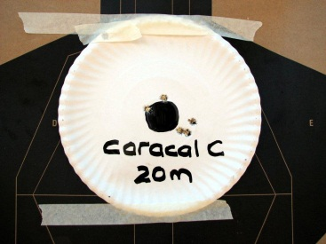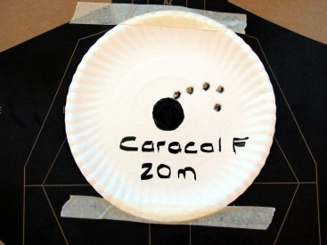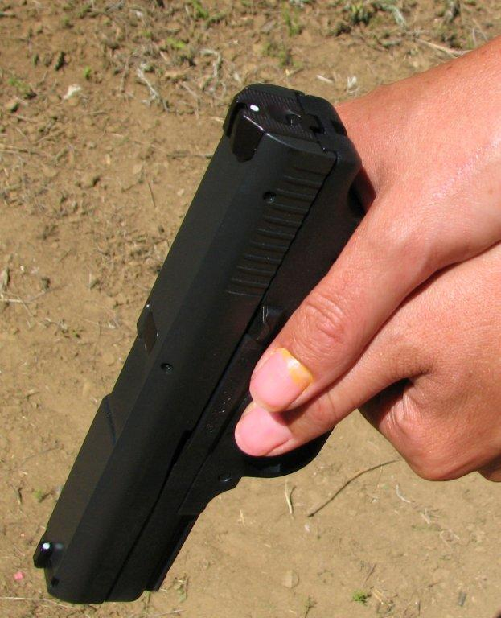
In view of its more concealable profile and smaller size we pressed a young feminine colleague, who is a debutante in the business of armed self- defence and therefore a good test subject, into running the compact model through some three metre speed drills into multiple targets simulating a home invasion by armed bad guys. She had no problem into putting eight shots - in the form of well centred double taps, fired instinctively from the isosceles position, into each of four quite widely spaced silhouette targets, in a very respectable 4,64 seconds from the timer’s beep to the last shot.
I ran various speed drills from 3, 5, 7 and 10 meters, through the compact– firing in total 160 rounds without any incident or stoppage. Combat accuracy was more than adequate.
Moving on to the full sized model, I started off by punishing the weapon by “finger-fanning” the trigger through three full magazines loaded with standard PMP ammunition. This test consists of taking a firm strong-hand grip on the pistol and with the barrel safely pointed into a heap of soft sand, fanning the trigger with the forefinger of the weak hand inside the trigger guard as fast as possible, with the right elbow tucked firmly into your side. (Don’t try this at home!) This test empties the magazine at virtually the same speed as a sub-machinegun and will show up any feeding or slide stop flaws in a semi-auto pistol that could otherwise remain hidden. The Caracal passed without a glitch. The, by now very hot pistol, was subsequently fully loaded with a variety of 18 hollow points in the magazine and 1 in the chamber – all in high performance +P or +P+ configuration. The combination consisted of Speer (Gold Dot), Winchester (Ranger SXT) and Federal (Hydrashok). Coming as it did from a desert nation I assumed the Caracal could digest a bit of sand. I therefore “accidentally” dropped it quite deeply into a heap of dirt, kicked a bit more sand over it and, after picking it up and shaking it without opening the slide or removing the magazine, fired the full contents of chamber and magazine as rapidly as possible into the four silhouettes.
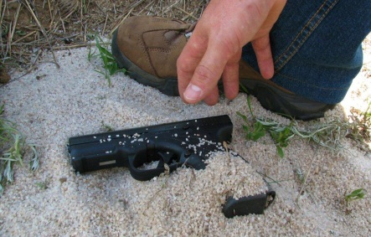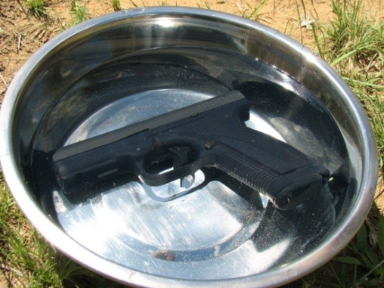

After the last shot the slide stop engaged and the test had gone perfectly smoothly. Loading it up again in similar fashion with 19 +P+ rounds I then dropped our very hot gun into a bowl of water, where I left it until the bubbles stopped popping up to the surface. After retrieving the weapon, shaking it briskly a few times to remove any excess water it was rapidly fired as before with the same results – no stoppages occurred and the slide held back as it should after the last shot.
Both of the above tests pose inherent dangers and should never be attempted by any reader. My motivation in performing the experiments was merely to ascertain how the weapon would perform under extremely adverse conditions.
We then proceeded – using less expensive standard velocity hollow point Prvi Partizan ammunition – to run a number of speed drills from the 5, 7 and 10 metre marks on multiple targets with the same full sized Caracal carried strong side in a carbon composite polymer retention holster from the “Serpa” Blackhawk series. All test drills were timed and started from the holster. On each occasion four silhouette targets were engaged with a minimum of eight or maximum of twelve shots fired during each drill. (Either four centre-of-mass double taps or four double taps combined with four individual head shots). In each case only the appropriate number of rounds to complete the exercise was loaded to test the ability of the slide-stop - ensuring that the slide stayed back at the end of each application. Both strong and weak hand unsupported drills were also conducted without any stoppages occurring. A total of 340 rounds were expended in the tests conducted on the large frame Caracal without cleaning or oiling the firearm in any way and as previously stated there was not a single stoppage of any nature during the tests. Combat accuracy was excellent with the vast majority of the impacts clustered around the centre of mass and the average speed of splits on the double taps was marginally faster than with the compact version.
One swallow does not a summer make and expending approximately 500 rounds on the two pistols can hardly be described as extensive testing. There is however no doubt that no expense was spared in the design and manufacture of this pistol. Money is not in short supply in this oil rich Arabian region and exhaustive NATO and German army tests have apparently been successfully conducted on the product.
Without a significant price advantage over similar polymer framed offerings from Glock, Smith & Wesson and Springfield the Caracal is likely to get off to a bit of a slow start in South Africa. I personally find the full-size model offered as a complete kit with detachable stock, three magazines, fore-end grip and magazine loader an attractive package. While this interesting firearm may not sell as well as the proverbial hotcakes in our country, I do foresee a lucrative market for the product in middle-eastern and other parts of the world where an alternative to firearms from the United States is deemed attractive. With the ”Arab Spring Uprisings” turning into a “Prolonged Winter Standoff” the Caracal pistol may well outbreed its feline namesake in that unstable part of the world. Would I confidently carry either of these Caracals in a self-defence role or for sport-shooting purposes if my trusted Glock 19 was temporarily unavailable to me? The answer is an unequivocal “Yes” – but only after I have painted out that irritating back sight!
Stay safe.
Louis Steyn
July 2014
Specifications
Caracal Compact | Caracal Full Size
Caliber 9X19(9mmP) | Caliber 9X19(9mmP)
Weight 700g | Weight 750g
Height 122mm | Height 135mm
Magazine capacity 15 | Magazine capacity 18

